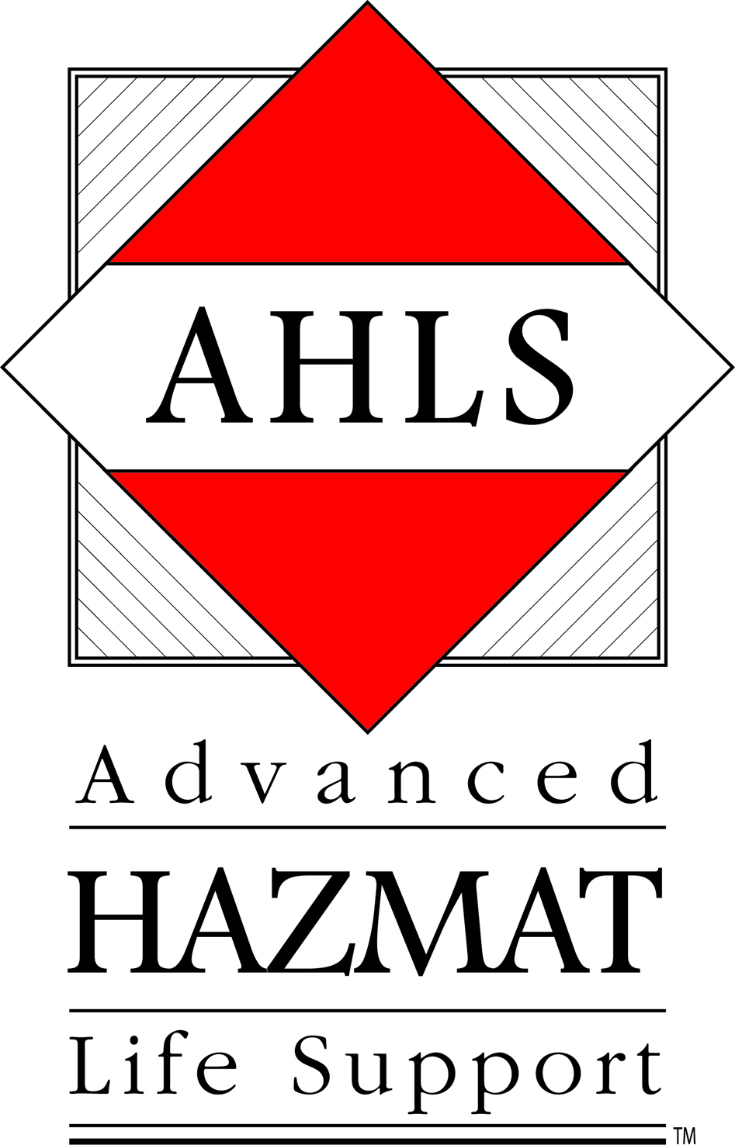

AHLS Provider Course and AHLS for Toxic Terrorism Course approved for ODP/Grants & Training Funding

The Advanced Hazmat Life Support Provider Course has been approved by the Office of Domestic Preparedness. (The letter of approval is on the back of this page). The AHLS for Toxic Terrorism Course has also been approved (a link to the approval letter appears on the AHLS website). Funds are distributed by ODP through the Homeland Security Department and are given to each state’s Homeland Security Director.

Since AHLS is an approved course, no application process is necessary to get AHLS approved by individual departments. Funds can be applied for by contacting your state’s Homeland Security Director. AHLS is not assigned a course number because we are considered a Non-ODP sponsored course. However, the letter on the back of this page serves as the approval notice you can use to show our course is approved. However, each state has defined Homeland Security goals, and your state Homeland Security Department must confirm that the course matches the state goals.

These funds can be used to host a course or to send individuals to the course. It even covers out of state travel and expenses.

This is great news and should allow for people to attend our courses more easily by using these funds. We have a link on our home page to this letter so that you can access it easily in the future.

If you have any questions or suggestions, please contact me.

Danielle Crounse
AHLS Program Coordinator
520-626-1982
danielle@aemrc.arizona.edu

PO Box 245057, Tucson, AZ 85724-5057
520-626-2305 520-626-1982 Fax: 520-626-7673
www.ahls.org ahslinfo@aermc.arizona.edu

January 7, 2005

MEMORANDUM TO: Maine Emergency Management Agency
ATTN: Bruce Fitzgerald
72 State House Station
Augusta, Maine 04333-0072

FROM: Howard Sellers
Director of Training
Center for Domestic Preparedness

SUBJECT: UASI state and local WMD training program
analysis and validation

The purpose of Urban Area Security Initiative (UASI) state and local WMD training program analysis and validation process is to ensure that state and local jurisdictions seeking Office of State and Local Government Coordination and Preparedness (SLGCP) approval of their WMD training course materials are submitting training products that are congruent with the standards and guidelines of the SLGCP training partner course assessment and approval process.

Upon receiving the SLGCP Training Approval Template submission for the Advanced HazMat Life Support – Provider Course (File #040723-01), the Center for Domestic Preparedness (CDP) conducted a desk audit of the course materials based on the completed template, the completeness of the materials submitted, and the content to determine if the training materials were consistent with SLGCP standards.

Analysis and evaluation of the submitted material(s) found that the training course meets these standards. The basis of this conclusion is contained in the attached course evaluation, observations, and findings. Any questions regarding this audit should be directed to Trisha Rayner, Chief, Evaluations and Standards Branch, Center for Domestic Preparedness, Anniston, Alabama, 36205, (256) 847-2308.

NOTE: In accordance with Fiscal Year 2005 Homeland Security Grant Program guidelines, this course has been given approval for each of the 56 states and territories to deliver, as long as the State Administrative Agency (SAA) believes that this course corresponds with their State Homeland Security Strategy.

